National University of Sciences & Technology

School of Electrical Engineering and Computer Science

Department of Computing

CS 213 Advance Programming (3+1): BSCS-7AB Fall 2019

|  |  |
| --- | --- |
| Assignment 1: CRUD and AMS in Express.Js | |
| CLO 3: Develop applications and tools using various frameworks | |
| Maximum Marks: 10 | Instructor: Dr. Sidra Sultana |
| Announcement Date: 15th Oct., 2019 | Due Date : 23rd Oct., 2019 5:00 pm on LMS |
| Name: Zunaira Salam | **Reg.No:214255** |
| Section: 21425 |  |

**Scenario**

Code Product manager with name, desc, price, category, image and reviews where only authentic user (the one who owns the product) can add, update and delete product. Admin can add users and assign roles as saler and buyer.

**Index.pug**

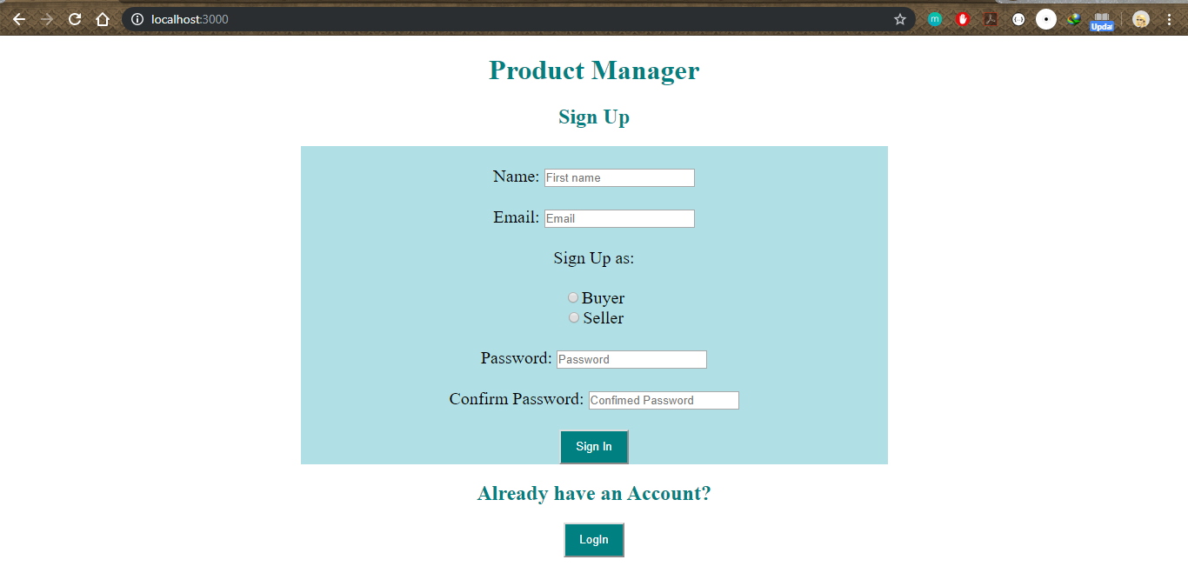

**Signup error**

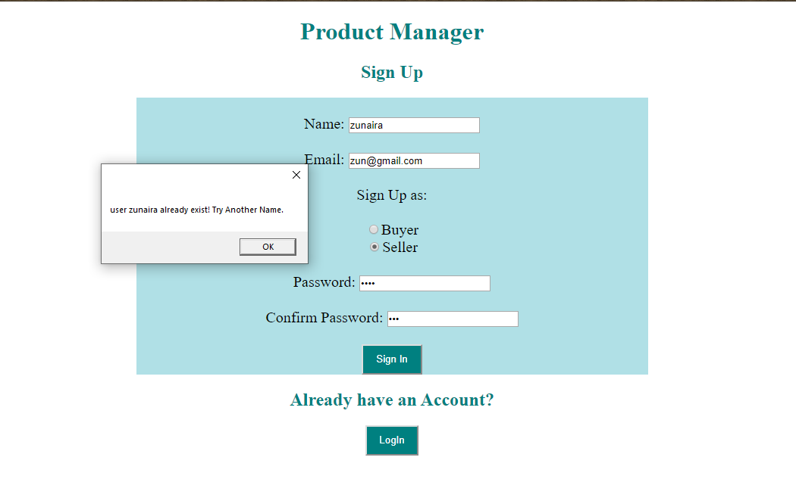

**Password error**

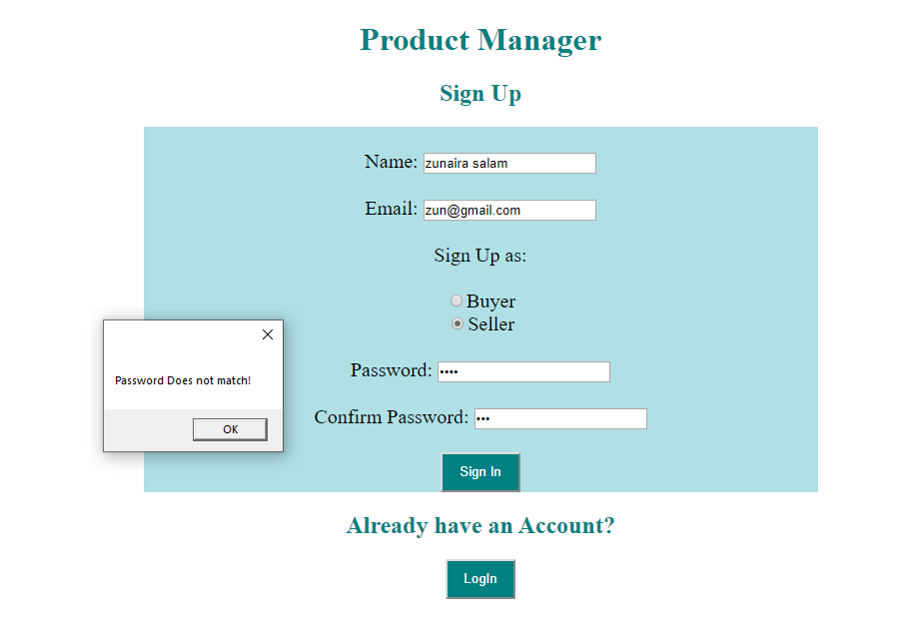

**Seller View:**

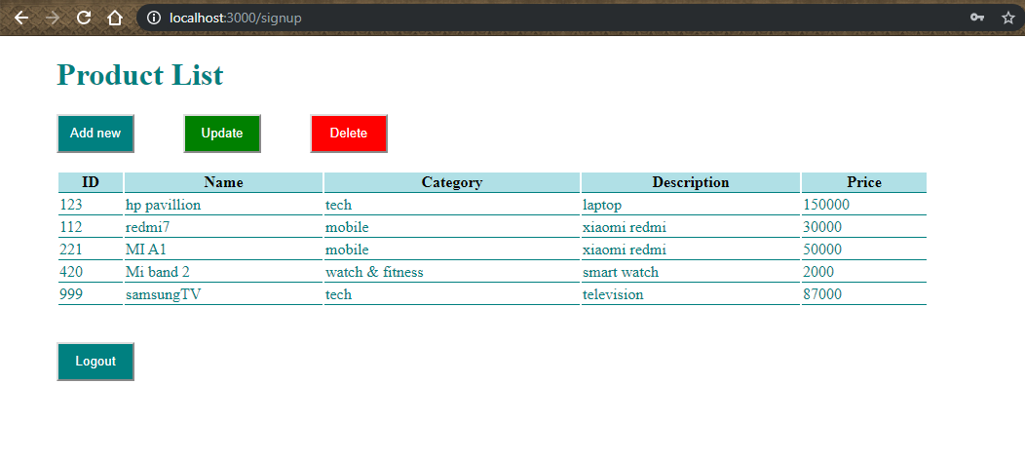

**Login View**

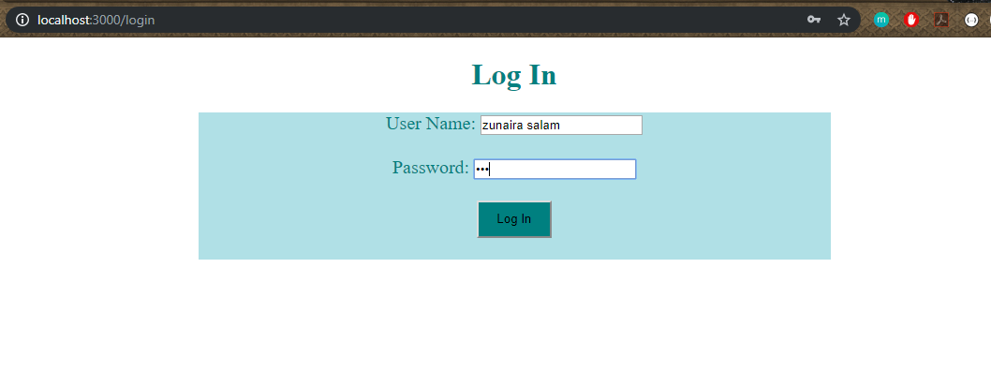

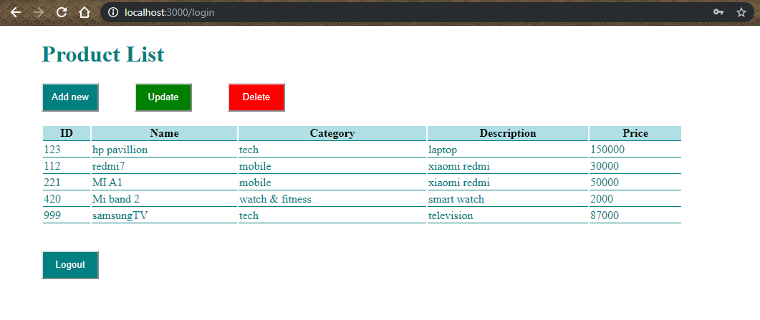

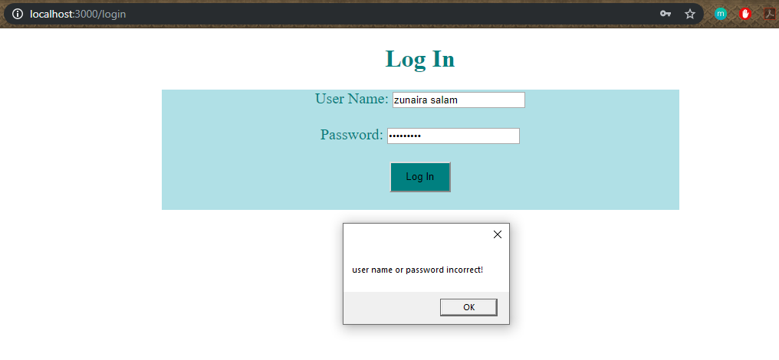

**Signup as buyer:**

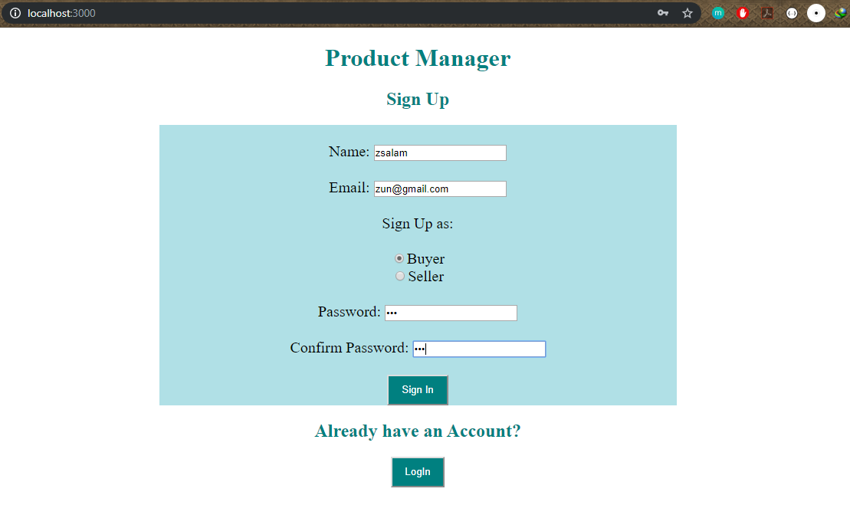

**Buyer View:**

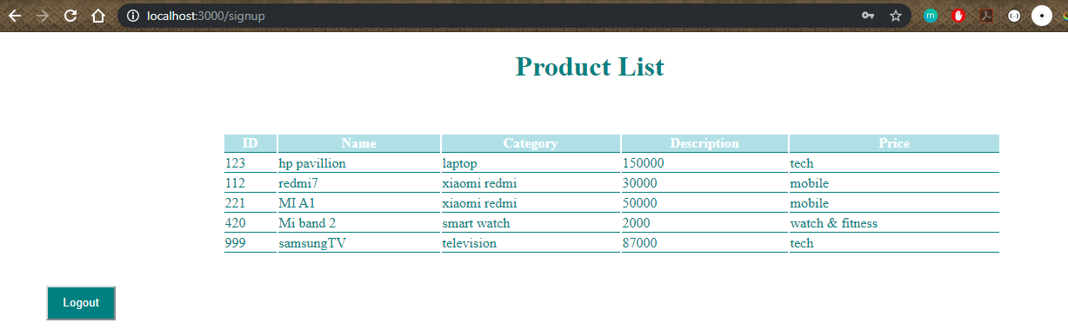

**Add New Product:**

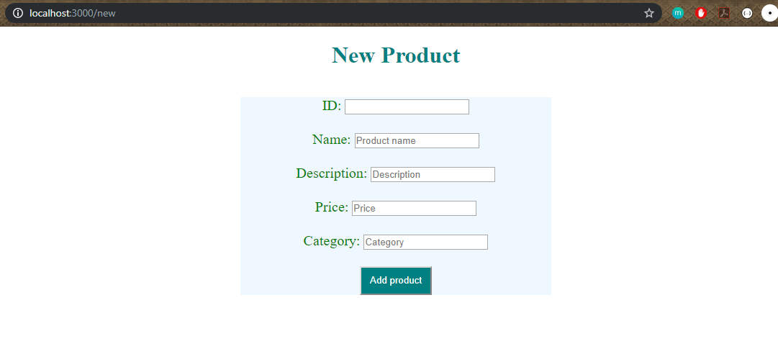**Add New Product Error:**

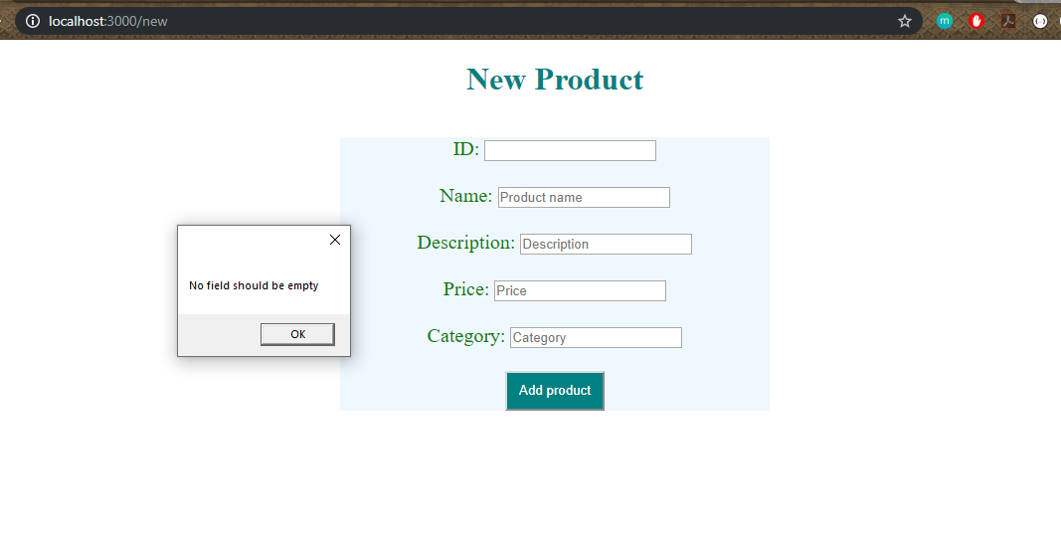

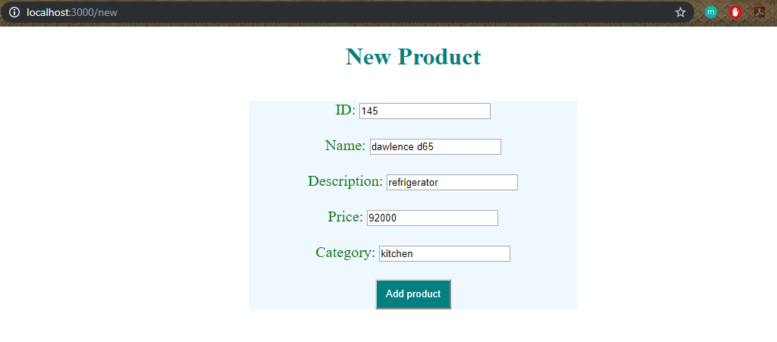

**New Product Added:**

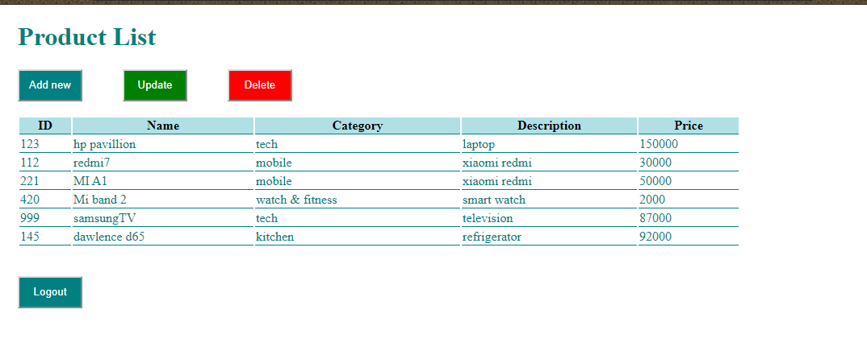

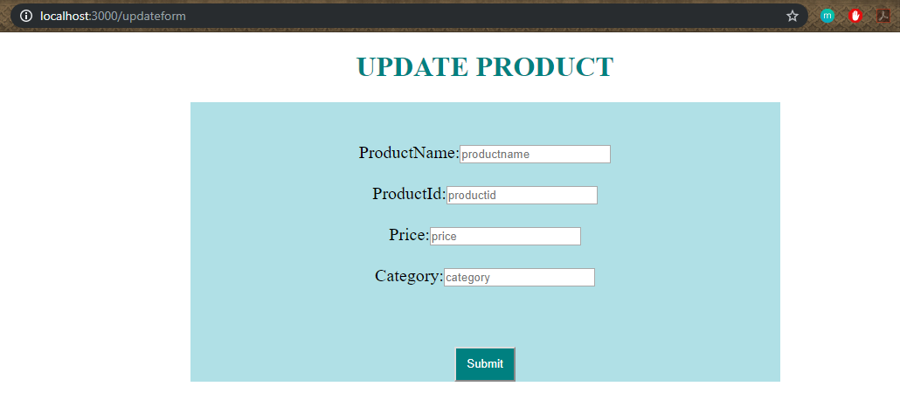

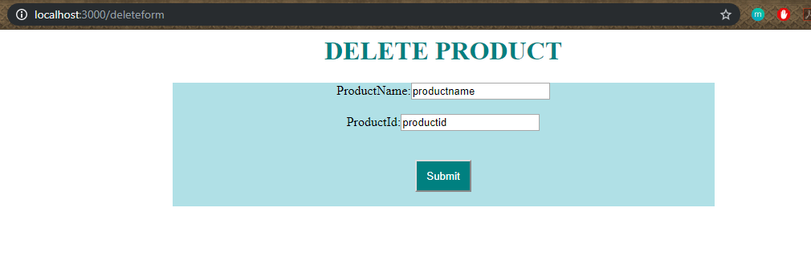

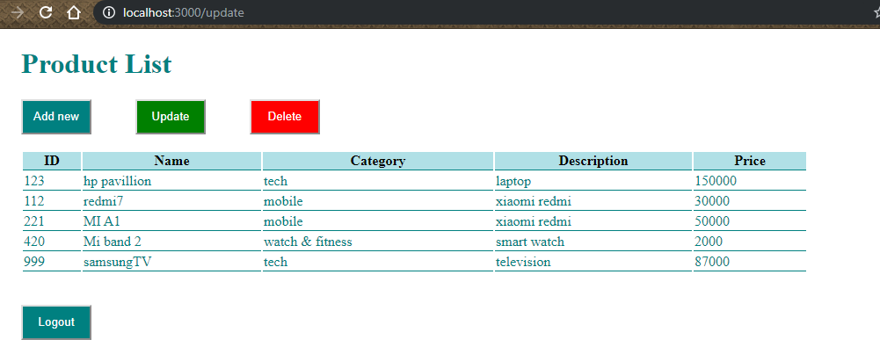

**Log Out:**

